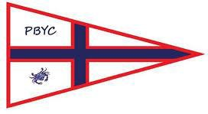

**PORT BOUVARD YACHT CLUB**

**WELCOME**

**New Members Information Book**

# PORT BOUVARD YACHT CLUB

## NEW MEMBERS INFORMATION BOOK

Dear New Member,

Welcome to the Port Bouvard Yacht Club. We are one of the sporting sections within the Port Bouvard Recreation and Sporting Club. Our focus is on encouraging people of all ages and experience to enjoy the activity of sailing on some of the best waters in Western Australia.

Our aim is to have a club where you can sail with minimal costs. Our fleets allow for a variety of off the beach catamarans and monohulls as well as trailer sailer yachts of all types.

The club actively seeks the input of new members, and we appreciate your involvement in sailing and social activities. One of our important aims is to grow membership and to this end we encourage a friendly atmosphere above all else

I extend a personal invitation for you to contact any representative of our committee at any time with suggestions and feedback to help make our club better meet the needs of our members.

I wish you safe and enjoyable sailing.

Commodore

Port Bouvard Yacht Club

# CONTACT DETAILS

## Club Address

Port Bouvard Yacht Club

*A division of* Port Bouvard Recreation & Sporting Club Incorporated **Port Bouvard Recreation and Sporting Club contact details:** Address: 1Thisbe Drive, Dawesville, WA, 6211

Office Telephone: 9582 2871

Office Hours: Hours – Monday 10am – 3pm / Tuesday to Friday 9am – 3pm PBRSC email: [admin@pbrsc.org.au](mailto:admin@pbrsc.org.au)

PBRSC website: [www.pbrsc.org.au](http://www.pbrsc.org.au/)

PBRSC Social Media: <https://www.facebook.com/pbrsc>

### Port Bouvard Yacht Club contact details:

**Commodore pbycommodore@gmail.com**

**Secretary pbycsecretary@gmail.com**

**Treasurer pbyctreasurer@gmail.com**

**Website: www.pbyc.org.au**

Social Media: <https://www.facebook.com/pbyc>

## Yacht Club Committee

**The Yacht Club committee is made up from the following positions. If you are interested then we welcome new nominations at our AGM held in July each year.**

|  |  |  |  |
| --- | --- | --- | --- |
| **Commodore** |  |  |  |
| **Vice Commodore** |  |  |  |
| **Rear Commodore** |  |  |  |
| **Secretary** |  |  |  |
| **Treasurer** |  |  |  |
| **Registrar** |  |  |  |
| **Bosun** |  |  |  |
| **Webmaster** |  |  |  |
| **Outrigger Captain**  **Class Captain**  **Security and Assets Coordinator** |  |  |  |

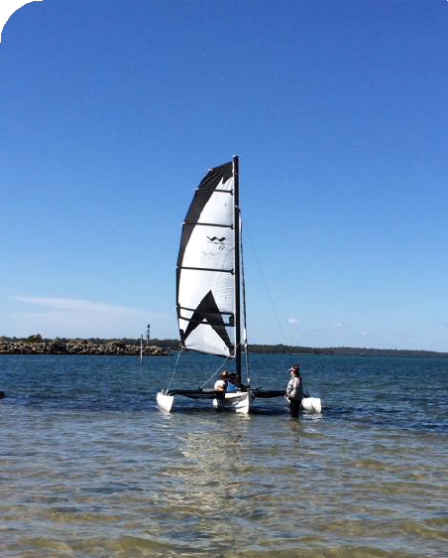

**Sailability Program Coordinator**

[pbycsail@gmail.com](mailto:pbycsail@gmail.com)

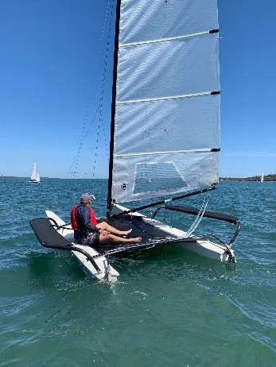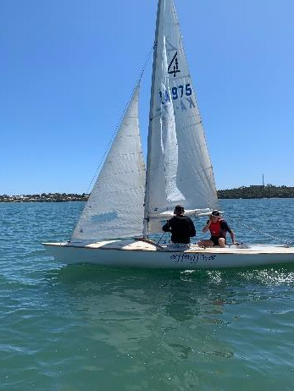

# CLUB HISTORY

Our all-age’s yacht club is friendly and family orientated located adjacent the southeast corner of the Dawesville Cut on the Peel/Harvey Estuary (also publicly known as the Mandurah Estuary).

We are part of the Port Bouvard Recreation & Sporting Club (est: 1979), located at 1 Thisbe Drive, Dawesville. As our Yacht Club members are also members of the greater Recreation & Sporting Club you can access its Dining, Bar and other Sporting/Recreational Facilities, Functions and Events.

The class of yachts we sail in relatively sheltered inland estuary waters include:

* Juniors – Topaz & Taz
* Youth – 125 & Catamaran
* Adult – Flying Fifteens, Trailer Sailers, Lasers & Catamarans (different classes/sizes)

In addition to our Junior instructional program, we offer “Sailability” experiences for people of all abilities (including their carers with our instructors) with the opportunity to sail regardless of their level of ability, skill or personal circumstances.

The City of Mandurah has approved a Foreshore Redevelopment Plan for the rear beach of our site to enhance public access, amenities and landscaping. Council has commenced works to these developments with further works commenced in 2023.

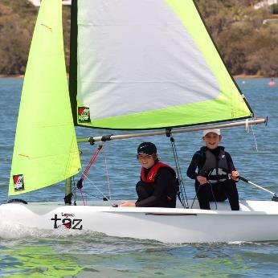Thank you for joining our club and we look forward to your participation in our activities.

# CLUB AFFILIATIONS

## AUSTRALIAN SAILING

Port Bouvard Yacht Club are affiliated members of the national body for the sport of sailing in Australia - *Australian Sailing* who promote grassroots to high level participation.

All current registered financial members of Port Bouvard Yacht Club have automatic individual cover for personal injury insurance and other benefits while racing, details of which are available at **https://**[**www.sailing.org.au/**](http://www.sailing.org.au/)



## SAILABILITY

Port Bouvard Yacht Club provides sailing opportunities for people with a disability regardless of their ability, mobility or circumstances. Via our support program we provide our club owned Windrider 17 Trimarans with a volunteer instructor for each disabled person and their carer(s).

Sailabilty is an international Organisation which gives people with difficulties the

opportunity to “sail”. The philosophy of “freedom” on the water is turned into a reality

for people of all ages, with a wide range of abilities.

We are proud members of Sailabilty which operates internationally in 19 countries worldwide with over 350 branches.

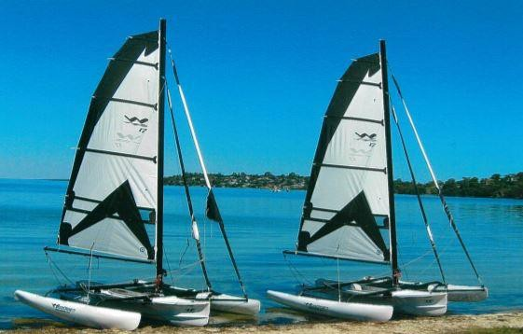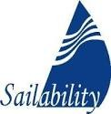

# CLUB CALENDAR

## SAILING SEASON

Our sailing season commences in October and ends in May, with sailing held every Saturday, including a scheduled race every week. The best place to get information about racing dates is in the clubhouse where they are posted or from the sailing calendar found on our website.

## BUSY BEE

These are held at different times of the year and all members are encouraged to come along and help out with the different tasks that need to be completed.

## OPENING DAY

This is generally after the end of the third term school holiday period and varies from year to year. The date for opening day is displayed on the club website.

## PBYC PLATFORM RACE –

We host an annual members and public invitation event which is open to all off the beach catamarans and monohulls and foiling craft including kite and windsurfing equipment. Starting in the estuary at the eastern end of the Dawesville Cut this event comprises a lengthy and demanding course for those seeking a challenge as it comprises a course running from the waters in front of the club south to the Harvey Estuary Marine Research Station, a distance of approximately 8 kilometres.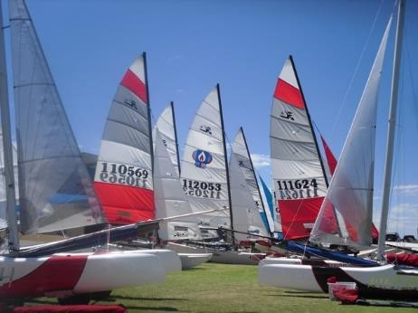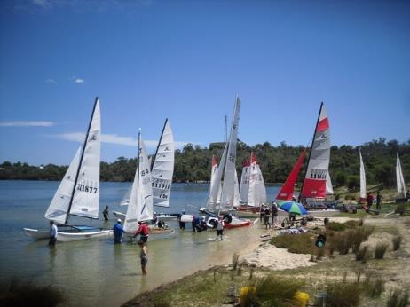

# CLUB FACILITIES

## ON SITE YACHT & BOAT STORAGE

For an annual fee, a FOB access security gate key is available for access to the club site at any time during the week. Please note that the site is shared by John Tonkin College and the school’s activities should not be interfered with. Hardstand bays are also available to any full financial member of the PBR&SC.

Please note that late or non-payment of fees will result in your access to the club being denied.

Members are responsible for fully insuring their own yachts and boats while stored on the hardstand. The cost of repair (or replacement) due to any physical damage

caused by a member to another member’s yacht or boat is the complete responsibility of the member initially causing such damage. Members are to ensure no flammable or dangerous goods are stored on their yacht or boat on the hardstand. The bays are for boat storage only and no other materials can be stored there. Boats need to be secured and able to be moved quickly in case of an emergency and remember one boat or trailer per bay only.

## CAR PARK

On site car parking is available to yacht club members and their guests on the hardstand adjacent the main entry gate. The carpark is not to be used for long term parking.

## BAR & BBQ FACIILITIES

The yacht club does not have a legally compliant licensed bar on site as members are encouraged to use the facilities located in the Port Bouvard Recreation & Sporting Club, Dawesville.

Our BBQ is available for use by Members who are to ensure it and the area adjacent are properly cleaned after use.

## KITCHEN & FRIDGE FACIILITIES

The club kitchen may be used by members with approval from a Canteen Volunteer. Users are to respect other Members by ensuring the kitchen is thoroughly cleaned after using this space and any utensils. Preordered snack meals (limited) can be pre ordered/purchased on sailing days from Club Volunteers. A member’s fridge is available for food and drink storage. Bulk ice is not available to members or guests.

## AMENITIES

To the rear of the Clubhouse, our Unisex Toilet/Shower is accessed via a punch in security number provided to members who are to ensure they are left properly cleaned after use.

## WASH DOWN

Hose facilities external to the Clubhouse are to be used by members and guests for yacht/boat wash down and general hand cleaning.

## JOHN TONKIN COLLEGE MARITIME TRAINING FACILITY

Port Bouvard Yacht Club and the John Tonkin College Maritime Training Facility are co- located in a gated secured facility on the estuary foreshore at the City of Mandurah’s south-east Dawesville Channel multi use site.

Yacht Club Members are to fully respect the rights and access to the John Tonkin Facility by its users and to ensure its building, grounds and environs are maintained in a clean and proper state at all times.

## USE OF CLUB HOUSE GROUNDS FOR FUNCTIONS/EVENTS/CAMPING

The PBYC Committee will consider requests for use of the club grounds (external to buildings) for the purposes of functions. Please approach a committee member or contact [pbycsecretary@gmail.com](mailto:pbycsecretary@gmail.com) to enquire.

After securing written committee approval for function/event use a suitable fee and bond will be required from the member(s) commensurate with the type, size and duration of the proposed function/event. Monies will be taken from the bond as determined by the committee to pay for any damage and required clean-up costs of returning the grounds to its original condition.

Some members of the club have 24-hour access to the club for their use and any member holding a pre-approved event will respect these rights. Equally members having 24-hour access will respect the rights of those holding functions/events and avoid disrupting same.

The PBYC Committee will also consider short term camping during sailing events. Approval is required and may incur a small fee.

# RACING

## CLUB RACING INSTRUCTIONS BOOK

Our separate Club Sailing Book contains pre-race registration/entry and briefing details, starting instructions, generic course layouts and safety information.

Our Sailing Book also contains information relating to the impacts of potential course changes, risk management and emergencies that may arise on the day. A hard copy can be located in the clubhouse.

## AUSTRALIAN SAILING

Races are conducted under the current rules of Australian Sailing and all members are expected to be conversant with/have a fundamental knowledge of these rules to ensure the safety and enjoyment of all participants.

Our race day Club Class Captains will also assist you with sailing rules and race start/participation information, their experience and knowledge.

When racing at our club, members (guests/other visitors) must be a member of PBYC, a Club affiliated with Australian Sailing or purchase a race day pass in order to ensure you/they are registered with Australian Sailing in order to qualify for personal on water insurance while racing that day. If you would like to purchase a day pass, you can do this by purchasing a SailPass. Please contact the registrar on [pbycregistrar@gmail.com](mailto:pbycregistrar@gmail.com) for further information.

Please note that only those participants with race insurance cover for their boat are permitted to take part in any official club race.

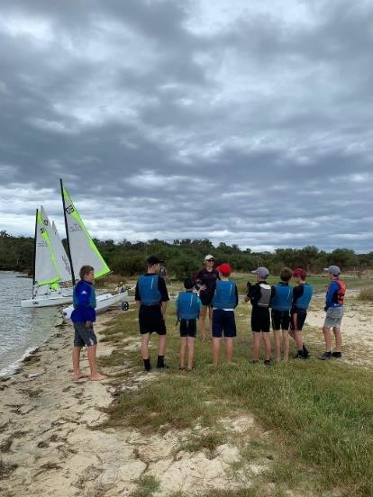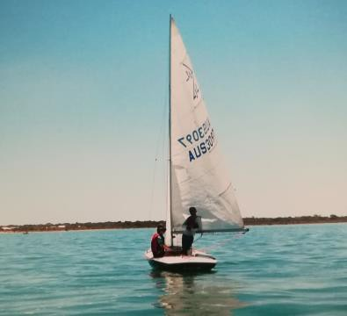

# MEMBERS RESPONSIBILITIES

## CONDUCT

PBYC expects members to conform to acceptable standards of dress and behavior while on our yacht club site, participating in club events or representing the club either on or off the water.

## BY-LAWS & CONSTITUTION

The current By-Laws and Constitution of the Port Bouvard Recreation & Sporting Club Incorporated including amendments thereto apply to the members, volunteers, and guests of Port Bouvard Yacht Club.

## CLOTHING

While PBYC does not have a dress code, casual clothing and footwear is encouraged at all times.

## DOGS

Owners are completely responsible for their dog(s) behavior and conduct at all times while at PBYC. Members are to particularly note that members of the public also access the beach area to the rear of our facility and dog owners are to ensure the safety of members and the public at all times. If in doubt - put your dog on a leash and please clean up after them.

## HEALTH & SAFETY

All members, volunteers and guests are expected to familiarise themselves with the emergency and evacuation requirements of the club.

When the Clubs activities are occurring, there is potential for accidents and injuries. Care should be taken at all times to acknowledge/negate potential hazards from moving vehicles, yachts and boats. It is the responsibility of members, guests, and volunteers to abide by the clubs OH&S policies. Any matters that require immediate attention should be reported to the Commodore or Committee Member.

Yacht and boat seaworthiness, safety and use of your boat in varied weather conditions is ultimately the sole responsibility of the owner/operator of the vessel.

## SMOKING

PBYC is a smoke free venue.

## VULNERABLE PERSONS SAFETY

It is imperative that all PBYC members and volunteers ensure that we continue to promote and provide a safe environment, particularly for Juniors (aged under 18) during their sailing, training activities and social interaction with adults at all times. This applies to any oral or electronic communication contact with Juniors either at or outside of the Club. Port Bouvard Yacht Club is committed to child safety and will ensure that all Juniors who engage with our Club - its members and volunteers do so in a safe environment. Port Bouvard Yacht Club’s Vulnerable Persons Safety Documentation can be located online via <https://www.pbyc.org.au/documents>.

## MEMBERSHIP FEES

The Port Bouvard Recreation & Sporting Club will invoice you directly for the payment of your annual fees. Please note that boat storage fees are invoiced separately. The current costs and fees can be obtained by contacting the PBR&SC on [admin@pbrsc.org.au](mailto:admin@pbrsc.org.au) or phone ***9582 2871***

## BOAT STORAGE

Subject to PBYC Committee approval, members can store their boats on the club grounds. Boat storage fees will be issued by the Port Bouvard Yacht Club and may be obtained by contacting the Commodore via email [pbycommodore@gmail.com](mailto:pbycommodore@gmail.com)

### Active membership

Members who race on a regular basis, have an Australian Sailing number and contribute towards club activities (such as busy bees, race day roster, club and ground maintenance) are considered active members and may received a discounted storage fee.

### Conditions of storage

Vessels that are seeking storage at the PBYC must have a minimum third-party insurance. The primary purpose of the insurance requirement is to protect other members stored boats against damage.

All boats must be able to be moved by the committee or their representative. This is a question of safety and action in the case of severe storms, fire etc. To this end tyres must be inflated, and nothing can be stored on the ground. Any equipment connected with the stored vessel must be stored on the vessel or removed from the hardstand.

Members should also familiarise themselves with fee structures and debt recovery

procedures outlined in the club’s fee structure document. Minor repairs by members of their vessels can be carried out on the hardstand. Major repairs must not be undertaken unless prior approval of the committee has been gained in writing.

### Liability

The member indemnifies the club (PBYC a section of the PBR&SC) against any claim for damages resulting from the loss of damage to the stored vessel and its components or personal injury or death resulting from the storage of said vessel and its components.

### Approval to store

Boat storage inquiries are to be discussed with the PBYC Boat Storage Officer. Committee approval must be gained and signed off on, prior to boats being brought onto the grounds for storage.

The approval to store a vessel and its components is for a period of 12 months from financial year to financial year. New approvals and new boat storage forms must be lodged at the start of each financial year. Note that accounts will be issued at the commencement of the financial year for the ensuing 12-month period.

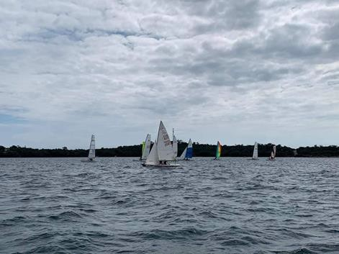

# VOLUNTEERS – ON WATER/ON SHORE

At the heart of any well-run sporting organisation are its volunteers who keep their club ticking.

Perhaps you are you interested (in addition to being a member) in volunteering to assist with a range of activities or know someone who would like to!

We need volunteers to take on roles including supporting our junior sailing section, in the galley and rescue boat skippers and crew. You may also want to be part of our team which promotes the joy of sailing as a recreation to our members and people with disabilities who participate in our Sailability program.

Please note that some of these activities may require statutory police clearances while assisting junior, youth and disability sailors.

While some sailing and boating skills may be required for our ‘On-Water’ activities, we can help and assist you with this. Please speak with any member of our committee to become a valued member of our volunteer program.

